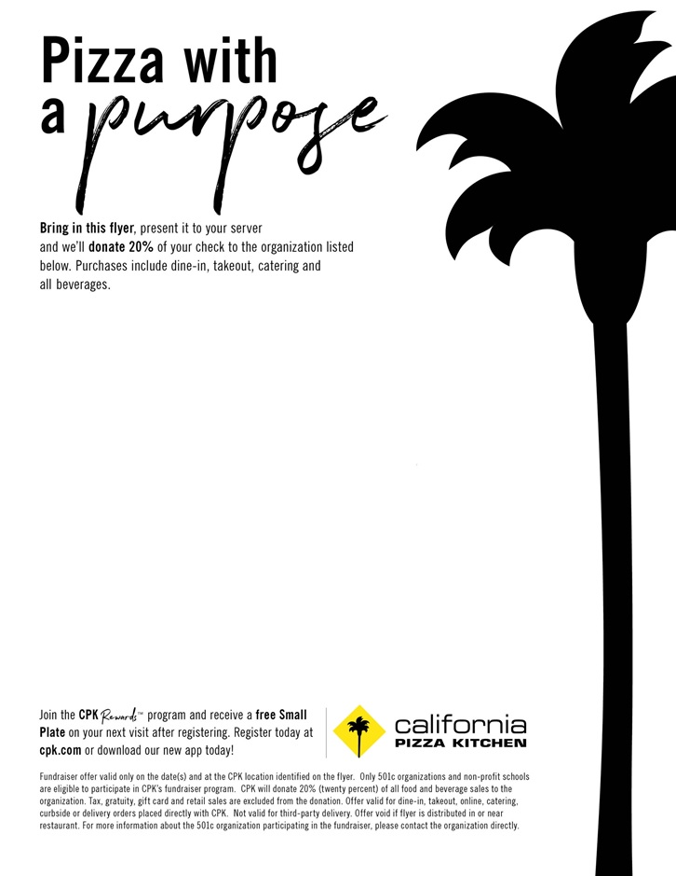

**Valid at the following location:**

**California Pizza Kitchen**Montgomery Mall

7101 Democracy Blvd.

Bethesda, MD 20817  
301.469.5090

**Fundraiser in support of:  
Wyngate Elementary School**Tuesday 2/12/19 & Wednesday 2/13/19  
(All Day)