Spring 2020 Courses at Wyngate Elementary

with

Tommie Shaw & Company
{New Choreography & Course Material}
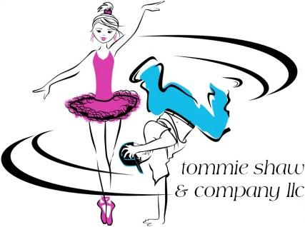

Beginner Hip Hop
Course is designed for both boys and girls
Wednesdays
Grades K – 4th
3:30 – 4:45
4/15/20-6/3/20
Tuition: $189.00
Click here to register
Or visit www.tommieshaw.com, click “Registration”, then click “Wyngate Spring Hip Hop”
Hip Hop is a high-energy dance form that uses the latest sounds in rap, R&B, and pop music, and is perfect for boys and girls who love to move! This fun-filled class immerses students in all aspects of motion, developing their balance, coordination and strength, as well as promoting creativity, teamwork, and self-esteem. We use child-friendly music in all of our Hip Hop classes (often Kids Bop), and all movement is age-appropriate. As always, classes this session will feature new music and choreography. Parents are invited to join us on the last day of class for a Parent’s Day performance.

Beginner American Sign Language {ASL}
Course is designed for both boys and girls
Mondays
Grades K – 5th
3:30 - 4:50
4/20/20 – 6/8/20; No Class on 5/25/20
Tuition: $189.00
Click here to register
Or visit www.tommieshaw.com, click “Registration”, then click “Wyngate Spring ASL”
Our Beginner ASL Course will accommodate both new and previous beginner level students by including new beginner level material! Explore a new world of communication by learning American Sign Language (ASL)! ASL is the fourth most commonly used language in the U.S., and learning ASL can open new lines of communication between hearing and hearing impaired individuals. Additionally, studies have shown that learning the ASL signs for letters and words can help children with spelling and vocabulary skills. The students will learn the signs for basic vocabulary terms and sentences in a fun, child-friendly environment. Parents are invited to join us on the last day of class for a Parent’s Day demonstration.

These materials are neither sponsored nor endorsed by the Board of Education of Montgomery County, the superintendent of schools, or this school.

Listed tuition price includes both an MCPS Room Rental Fee & Online Registration Processing Fee.

tommie@tommieshaw.com | 1530 Key Blvd. Suite 1029, Arlington, VA 22209 | office (703) 528-6454

